ASSIGNMENT NO. 13

Using UNION clause
Q.1. Create a union of two queries that shows that names, cities andrating of all customers . Those with rating of 200 or greater than will have the words “High Rating”, while the others have “Low rating”.

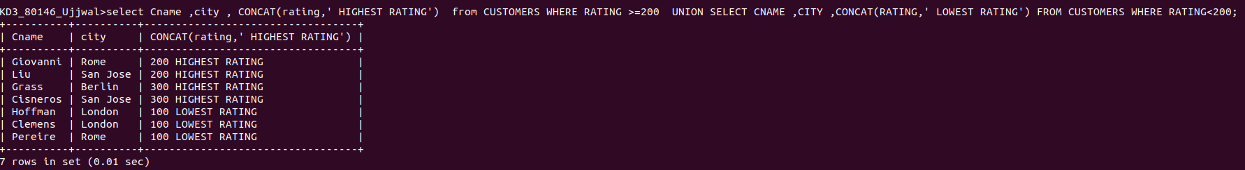

Q.2. Write a command that produces the name and number of each salesperson and each customers with more than one current order. Put the reasults in alphabetical order.

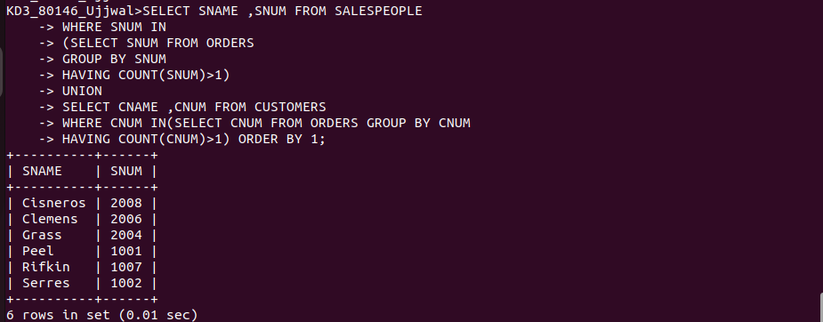

Q.3.Form a union of three queries. Have the first select the snum of all salespeople in San Jose; the second, the cnum of all customers in San Jose and the third the onumof all orders of october 3. Retain duplicates between the last two querries but eliminate any redundancies between
either of them and the first.

